Bitcoin Voice FAQ

**Overview:**

What is Bitcoin Voice?

What can Bitcoin Voice be used for, why is it useful?

**How to vote:**

How can I vote using Bitcoin Voice?

What wallets support voting?

How can I vote using Bitcoin Unlimited Cash?

**Website:**

Why do most issues on BitcoinVoice.IO seem irrelevant?

What does the “Total Unspent Output” column represent?

What does the “time period” menu mean?

**Details:**

What makes Bitcoin Voice censorship resistant?

How does Bitcoin Voice prevent spam and bots from voting?

Is Bitcoin Voice open source?

**Developer:**

Protocol Documentation:

How the total stake for an issue is calculated:

API documentation:

**Contact:**

PM me on Twitter: [https://twitter.com/BitcoinVoice/](https://twitter.com/bitcoinVoice/)

Overview:

**What is Bitcoin Voice?**

Bitcoin Voice is a voting platform for Bitcoin Cash that allows coin-holders to vote on any issues without censorship.

This is achieved via the two primary aspects of Bitcoin Voice:

1) BitcoinVoice.io, the website that allows anyone to easily see the current community consensus on any issue and to see what issues are currently trending/popular.

2) The Bitcoin Voice protocol (described in the protocol section below) that specifies the format for creating transactions for voting using Bitcoin Voice.

**What can Bitcoin Voice be used for, why is it useful?**

Bitcoin Voice allows for the Bitcoin Cash community to more easily determine the community consensus on an issue. For example, the block size limit debate could have been more easily settled using Bitcoin Voice.

There are always going to be contentious issues within Bitcoin and unless there are mechanisms that allow the Bitcoin community and its stakeholders to easily come to a consensus on these issues, often stagnation in adoption and development will occur as seen in Bitcoin Core prior to the fork.

In addition to speeding up the development and consensus process, Bitcoin Voice will make it significantly more difficult for censorship and confusion tactics to have any effect on the outcome as it allows people to instantly see what the consensus among coin-holders is.

How to vote:

**How can I vote using Bitcoin Voice?**

Voting in Bitcoin Voice is achieved by sending yourself a transaction containing the name of the issue that you want to vote on and the amount of coins that you would like to vote on that issue. Your vote will be valid until you spend the amount elsewhere.

**What wallets support voting?**

Currently the only wallet that supports voting is Bitcoin Unlimited Cash (<https://www.bitcoinunlimited.info/download>). Since Bitcoin Unlimited Cash is a full node and not very easy to use or install, we are actively working on an addition to <https://electroncash.org/> which will make voting a lot easier (because it is a lite wallet and easier to use than a full node wallet.) Voting support will be added to other wallets soon as well.

If you are a wallet developer, we would love to work with you to implement voting into your wallet. Contact us at @BitcoinVoice on Twitter.

**How can I vote using the Bitcoin Unlimited Cash wallet?**

To vote using Bitcoin Unlimited Cash (<https://www.bitcoinunlimited.info/download>), create a transaction that sends to yourself the amount of coins that you want to vote with and type the name of the issue that you want to vote on into the “Public Label” field in send page as seen below:

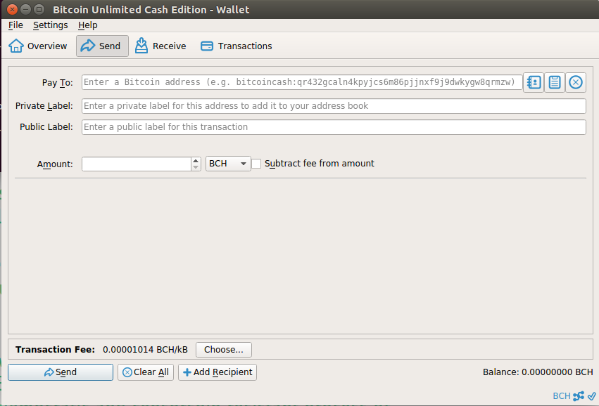

Website:

**Why do most issues on BitcoinVoice.IO seem irrelevant?**

Some posts from on-chain social media platforms such as Blockpress.com and Memo.cash show up because they use a similar protocol to what Bitcoin Voice uses. Although these make up the majority of topics on BitcoinVoice.IO now, once voting functionality has been added into Electron Cash (<https://electroncash.org/>), social media posts will be displaced by voting on actual issues since actual issues will have more Bitcoin Cash voted on them.

**What does the “Total Unspent Output” column represent?**

The “Total Unspent Output” column represents the total value of all (unspent) coins that have been voted on a particular issue.

**What does the “time period” menu mean?**

Changing what time period is selected filters votes by maximum age.

For instance, if you set it to “Week”, it will only take into account votes that were made in the last week when calculating the total unspent output for each issue.

Details:

**What makes Bitcoin Voice censorship resistant?**Bitcoin Voice is censorship resistant because, unlike websites like Reddit and other centralised platforms, all votes are stored on the blockchain and so can’t be altered, deleted or censored. Anyone can run their own copy of the BitcoinVoice.IO website as well since it is open source so they can verify the votes themselves.

**How does Bitcoin Voice prevent spam and bots from voting?**

Since all votes on Bitcoin Voice are weighted by the amount of coins they contain, making lots of votes won’t affect the outcome since, unless they contain a large amount of coins, their total weight will be small. In addition, there is a large incentive not to vote against what is beneficial for Bitcoin as that would potentially result in the value of your coins decreasing.

**Is Bitcoin Voice open source?**

Yes, it is completely open source. The GitHub repository is: <https://github.com/picrypto/bitcoinVoice>

Developer:

**Protocol Documentation:**

A vote in the Bitcoin Voice protocol is made by creating a transaction that includes a pair of outputs in the following order.

The first of the pair of outputs has an OP_RETURN that contains the name of the issue being voted on (encoded in hexadecimal). The following output contains the amount of coins being staked on that issue.

The transaction output index number (often called “vout” for output vector) is used to determine the order of the outputs. i.e. where this documentation refers to the “first output of the pair of outputs” and “second output of the pair.”

The reason a pair of outputs is used as opposed to just one OP_RETURN output is because the underlying bitcoin protocol makes any output that contains an OP_RETURN unspendable. Therefore we use a pair of outputs as described above to separate the coins being voted with into another (spendable) output.

A simple Bitcoin Voice vote transaction looks like this: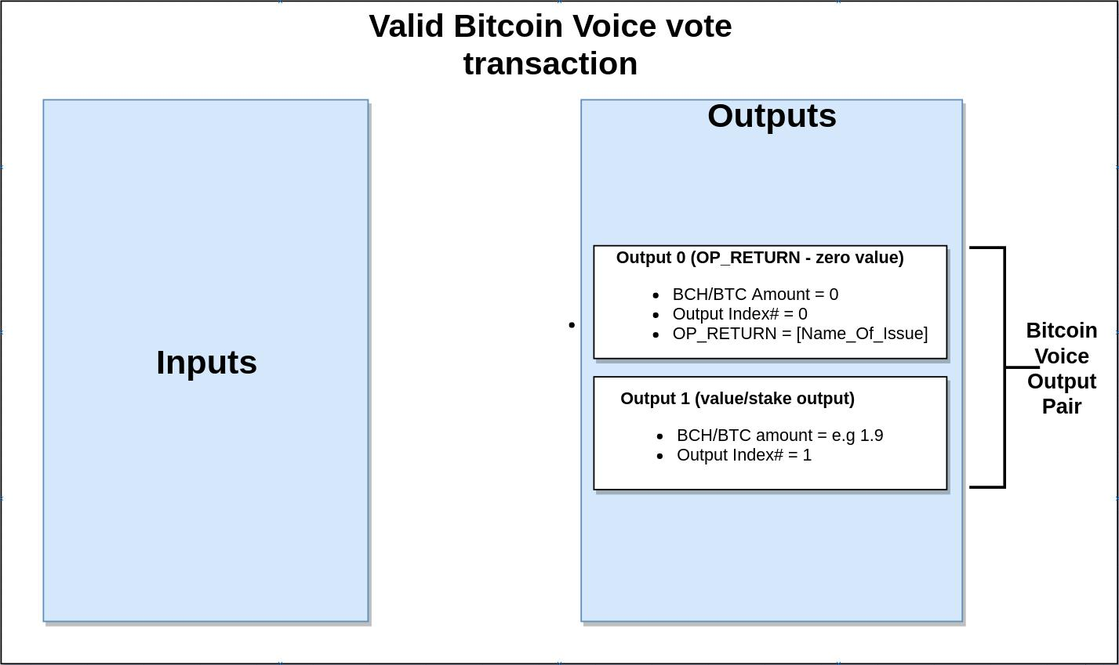

An example of a Bitcoin Voice vote transaction that is still valid but that contains other outputs looks like this: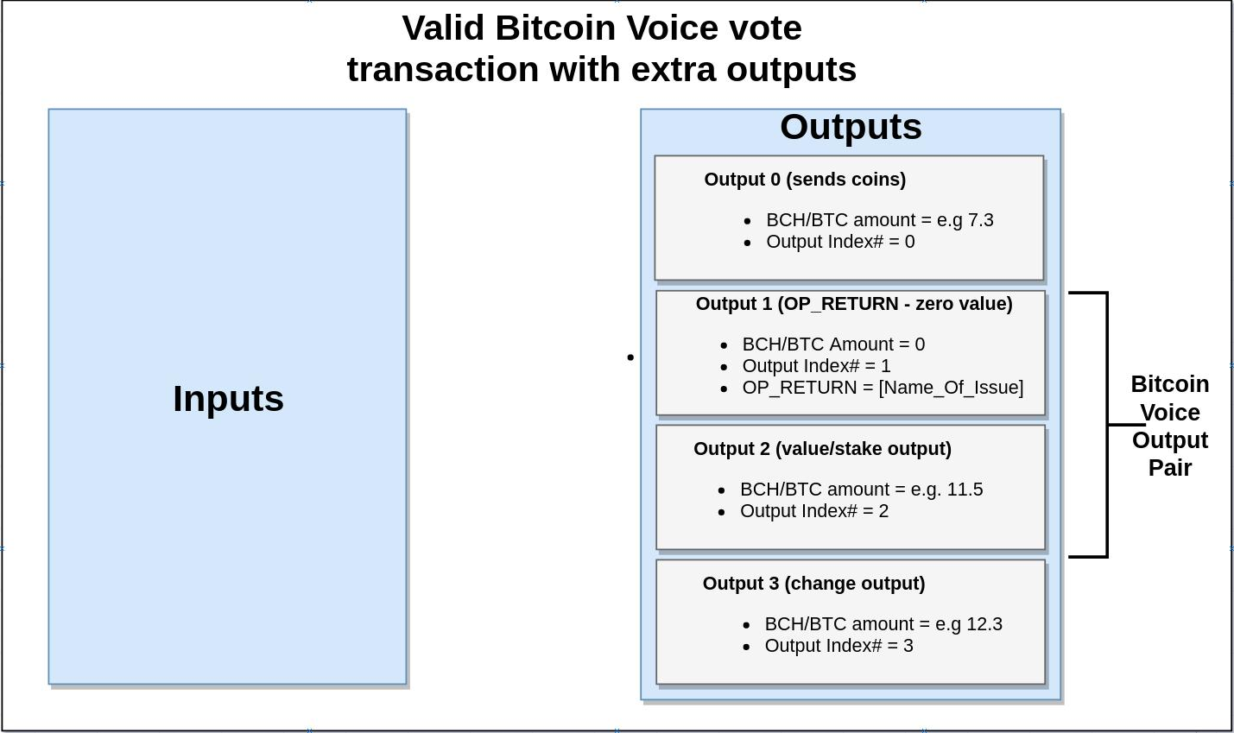

**How the total stake for an issue is calculated:**

The way that the total stake for an issue is calculated and the way that BitcoinVoice.IO calculates the “Total Unspent Output” column for a particular issue is by summing the amounts of the (unspent) stake/value outputs for all transactions with an OP_RETURN output containing the name of the issue.

Note - if the value output is spent (e.g. the owner decides to buy a uniform density spherical cow using that output) that amount will no-longer be counted toward the issue being voted on.

**API documentation:**

The BitcoinVoice.IO API allows you to programatically access a list of issues sorted by their staked amount (the amount of coins voted on them). It also provides access to information regarding what transactions contained votes for a particular issue. This is facilitated by the following two API endpoints:

***getPublicLabelAggregates***

Description: The getPublicLabelAggregates API endpoint returns a list of the top issues sorted by their staked amounts. The response is paginated with configurable page sizes.

Method: GET

Example request: <https://bitcoinvoice.io/api/?function=getPublicLabelAggregates&chainID=2&startPos=0&endPos=40&startDate=-344071039139.385&endDate=1528997169.632&searchTerm=big%20blocks>

Arguments: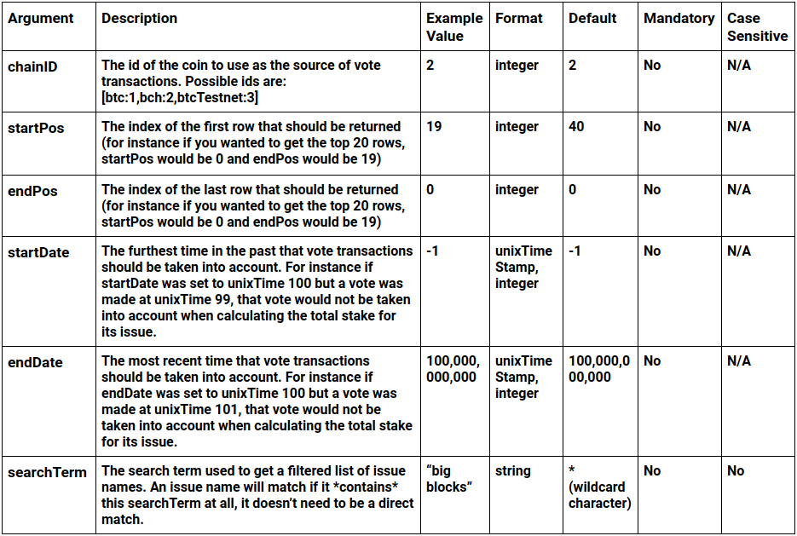

Response:

The response from this this API endpoint is a list of issue names that match the search criteria and their corresponding ranking in the returned list and their staked amount. The “amt” field in the response corresponds to the total amount of coins that are still unspent and that have been voted on that issue, it can be 0 and all this means is that all votes for this issue have been spent and so add up to 0.

Example response:

[{"rank": 1, "label": "Tasty Big Blocks", "amt": 19.2}]

***getPublicLabelOutputs***

Description: The getPublicLabelAggregates API endpoint returns a list of transactions sorted by their staked amounts that fit the Bitcoin Voice vote transaction specification and also contain an issue name that matches exactly to the one specified in the request to this end-point.

Example request: <https://bitcoinvoice.io/api/?function=getPublicLabelOutputs&chainID=2&startPos=0&endPos=40&startDate=-344071038858.775&endDate=1528997433.228&publicLabel=My%20Trezor&onlyUnspent=0>

Arguments: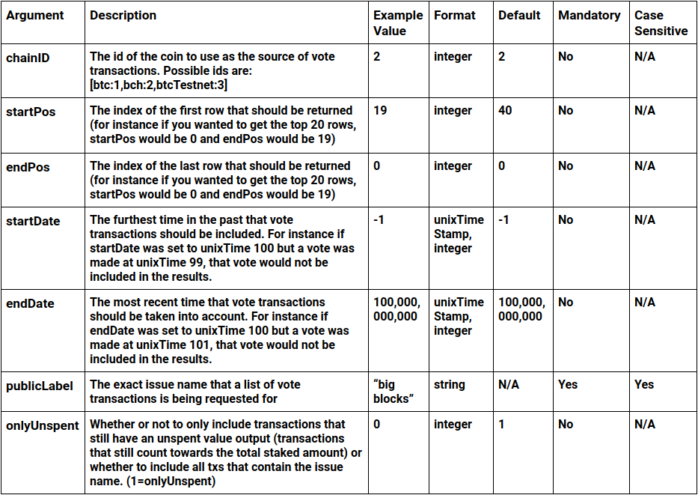

Response: The response from this this API endpoint is a list of vote transactions, sorted by their staked amount, that match the search criteria. Each transaction record in the response contains the following fields:

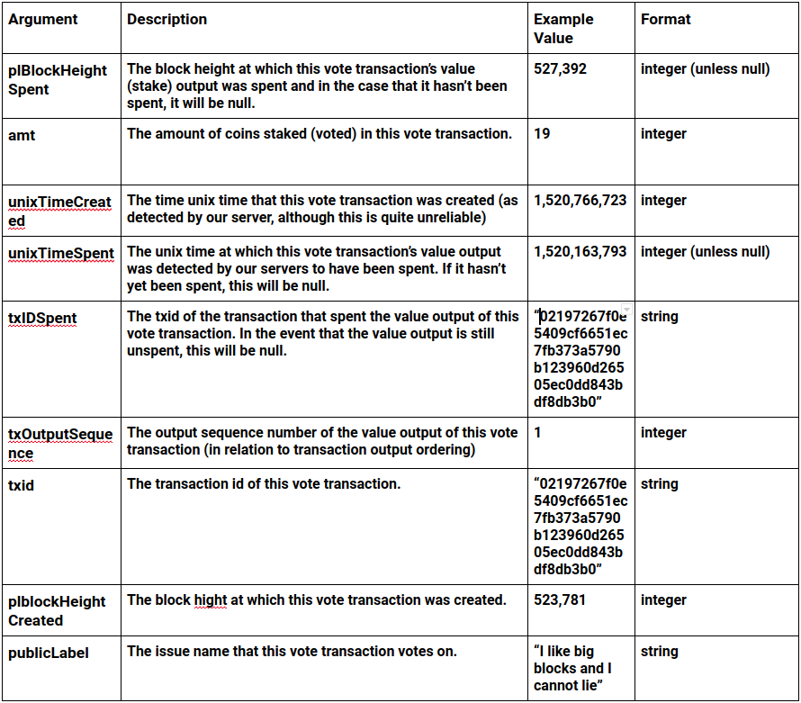

Example response:

[{"plBlockHeightSpent": null, "amt": 54.09497261, "unixTimeCreated": 1520766723, "unixTimeSpent": 0, "txIDSpent": null, "txOutputSequence": 1, "publicLabel": "My Trezor", "txid": "02197267f0e5409cf6651ec7fb373a5790b123960d26505ec0dd843bdf8db3b0", "plblockHeightCreated": 520930}, {"plBlockHeightSpent": null, "amt": 1.0, "unixTimeCreated": 1520762690, "unixTimeSpent": 0, "txIDSpent": null, "txOutputSequence": 1, "publicLabel": "My Trezor", "txid": "99fd800ebafea51b376b0b6480a895217d56c2334ab65f0331ed4d9aee62c3d5", "plblockHeightCreated": 520925}]

Contact:

**PM me on Twitter:** [**https://twitter.com/BitcoinVoice/**](https://twitter.com/bitcoinVoice/)